UML DIAGRAMS

CLASS DIAGRAM
The Class Diagram represents the static structure of the Constructa system. It defines the main classes such as User, HouseRequirement, FloorPlan, Engineer, CostEstimation, Material, Payment, and Feedback along with their attributes and relationships. This diagram helps in understanding the system architecture and serves as the foundation for database and table design.

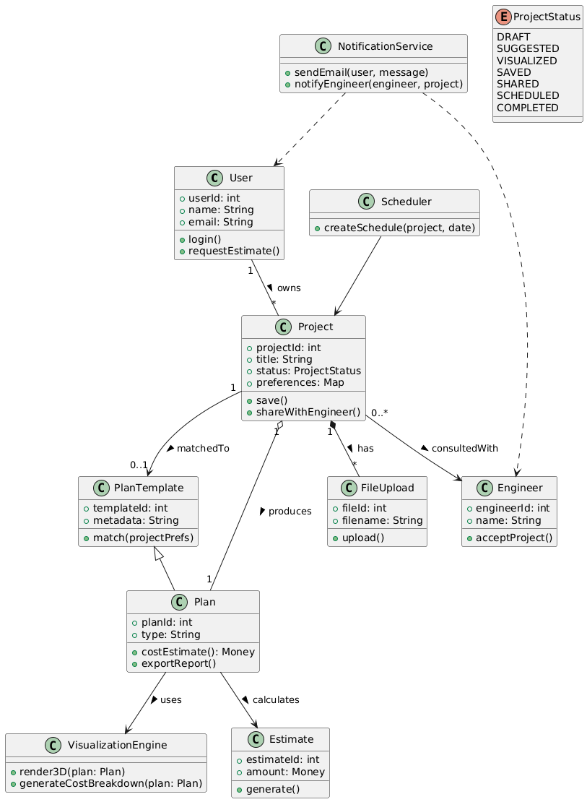

COMPONENT DIAGRAM
The Component Diagram provides a high-level view of system components such as Web Interface, Application Server, Authentication Module, Plan Recommendation Engine, Cost Estimation Engine, and Database.

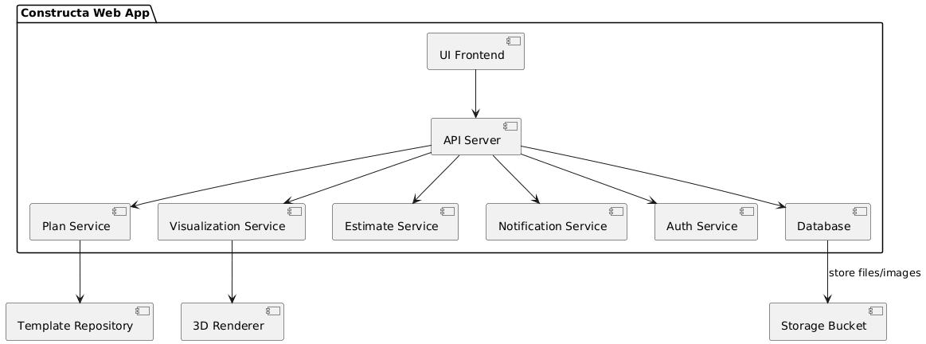

DEPLOYMENT DIAGRAM
The Deployment Diagram illustrates the physical deployment of the Constructa system. It shows the user accessing the system via a web browser, requests handled by the web server and application server, database storage on a separate server, and optional cloud-based services for scalability.

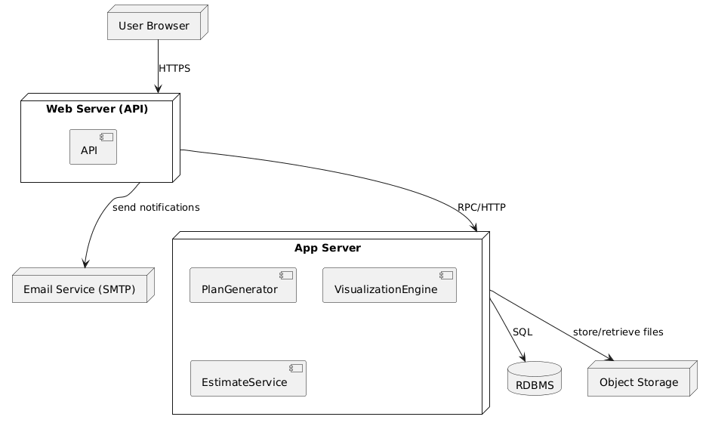

STATE CHART DIAGRAM
The State Chart Diagram describes the lifecycle of a house construction request. States include Submitted, Under Review, Plan Generated, Cost Estimated, Approved, and Completed. Transitions occur based on user actions and system validations.
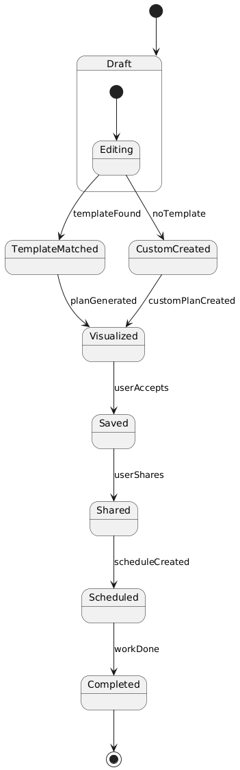

USE CASE DIAGRAM
The Use Case Diagram depicts the interaction between actors and the Constructa system. The primary actors include Admin, User (Homeowner), and Engineer. The diagram highlights key functionalities such as user registration, entering house requirements, viewing recommended plans, generating cost estimates, communicating with engineers, and managing system data.

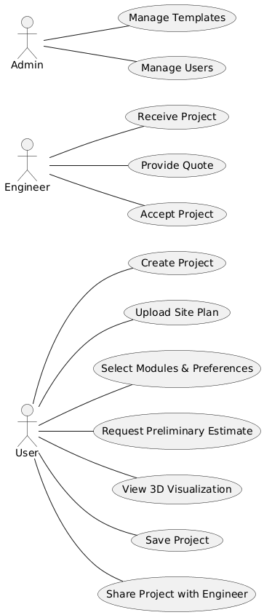

SEQUENCE DIAGRAM
The Sequence Diagram illustrates the flow of interactions when a user generates a house plan and cost estimation. The user submits requirements, the system validates the input, processes plan recommendations, calculates estimated costs, and finally displays the results to the user, ensuring a clear time-based interaction flow.

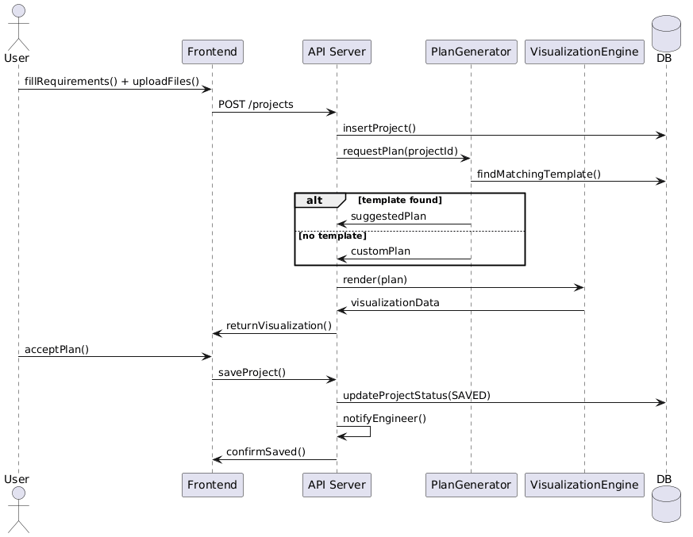

OBJECT DIAGRAM
The Object Diagram provides a snapshot of the system at a specific point in time. It shows instances such as a registered user, a selected house plan, an assigned engineer, and a generated cost estimation, illustrating how objects interact during real-time usage of the Constructa application.

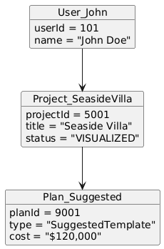

COLLABORATION DIAGRAM
The Collaboration Diagram focuses on how system components work together to fulfill a request. It shows interactions among User Interface, Requirement Module, Plan Recommendation Engine, Cost Estimation Module, and Notification Service while generating and delivering a personalized house construction plan.

ACTIVITY DIAGRAM
The Activity Diagram represents the workflow of the Constructa system. It begins with user login, followed by entering house requirements, validating inputs, generating plan suggestions, estimating costs, and displaying results. Decision points handle invalid data and allow users to re-enter details if needed.

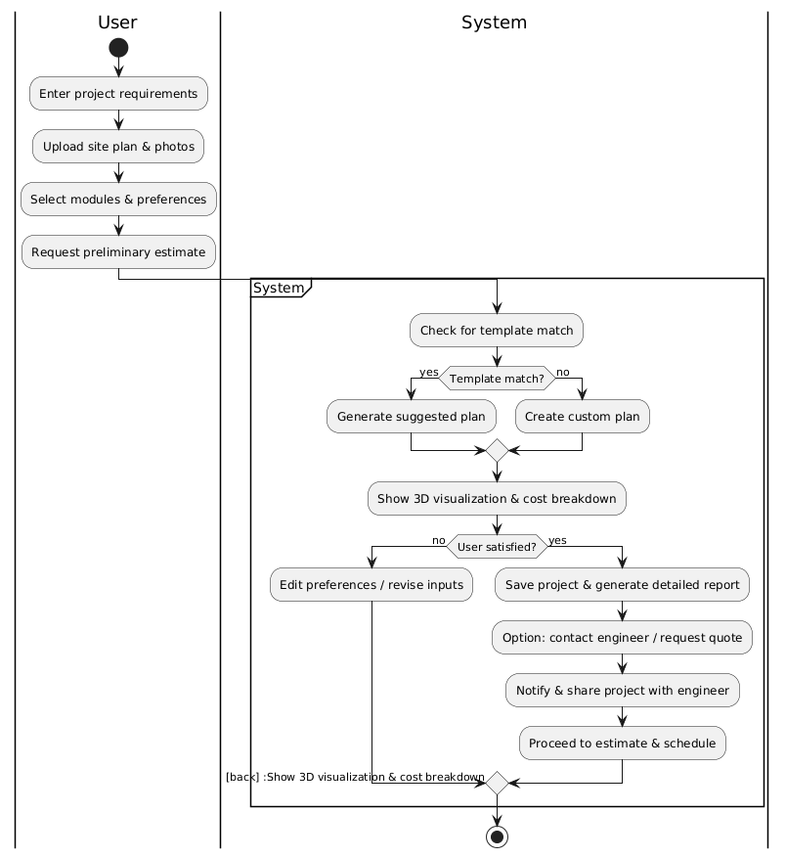

COLUMN | Type | Description
user | Int pk | Unique user identifier
Name | Varchar(100) | User full name
email | Varchar(100) | User email address
password | VARCHAR(255) | Encrypted password
phone | VARCHAR(255) | Contact number
role | VARCHAR(255) | User role (Admin/User/Engineer)

Table Design – Constructa

Users Table

House Requirements Table

Column | Type | Description
requirement_id | INT PK | Unique requirement ID
user_id | INT FK | References users(user_id)
plot_size | VARCHAR(50) | Plot dimensions
floors | INT | Number of floors
rooms | INT | Number of rooms
budget | DECIMAL | User budget

Floor_Plans Table

Column | Type | Description
plan_id | INT PK | Unique plan ID
requirement_id | INT FK | References house_requirements
plan_type | VARCHAR(50) | Type of house plan
area | DECIMAL | Total built-up area
description | TEXT | Plan details

Engineers Table

Column | Type | Description
engineer_id | INT PK | Unique engineer ID
name | VARCHAR(100) | Engineer name
specialization | VARCHAR(100) | Area of expertise
experience | INT | Years of experience
contact | VARCHAR(15) | Contact number

Cost_Estimation Table

Column | Type | Description
estimation_id | INT PK | Unique estimation ID
requirement_id | INT FK | References house_requirements
material_cost | DECIMAL | Material cost
labor_cost | DECIMAL | Labor cost
total_cost | DECIMAL | Total estimated cost

Payments Table

Column | Type | Description
payment_id | INT PK | Unique payment ID
user_id | INT FK | References users(user_id)
amount | DECIMAL | Payment amount
status | VARCHAR(20) | Payment status
payment_date | DATE | Date of payment

TABLE NORMALISATION

First Normal Form (1NF)
A table is said to be in First Normal Form (1NF) if:
- Each field contains atomic (single) values
- There are no repeating groups or multivalued attributes
- Each record can be uniquely identified by a primary key

Application in Constructa
- The Users table stores single values for name, email, phone, and role.
- The House_Requirements table stores one plot size, number of floors, rooms, and budget per record.
- The Payments table stores one payment amount and status per transaction.
✅ All Constructa tables satisfy 1NF because there are no multivalued or repeating attributes.

Second Normal Form (2NF)
A table is in Second Normal Form (2NF) if:
- It is already in 1NF
- All non-key attributes are fully functionally dependent on the primary key
- There is no partial dependency

Application in Constructa
- Each table uses a single-column primary key such as user_id, requirement_id, plan_id, etc.
- In the House_Requirements table, attributes like plot size, floors, rooms, and budget depend only on requirement_id.
- In the Cost_Estimation table, material cost, labor cost, and total cost depend entirely on estimation_id.
✅ Since there are no composite primary keys, partial dependency does not exist, and all tables are in 2NF.

Third Normal Form (3NF)
A table is in Third Normal Form (3NF) if:
- It is already in 2NF
- There is no transitive dependency
- Non-key attributes do not depend on other non-key attributes

Application in Constructa
- User contact details are stored only in the Users table and not repeated in other tables.
- Engineer details are stored separately in the Engineers table.
- Cost-related data is stored only in the Cost_Estimation table and linked using foreign keys.
- Payment details are stored independently in the Payments table.

